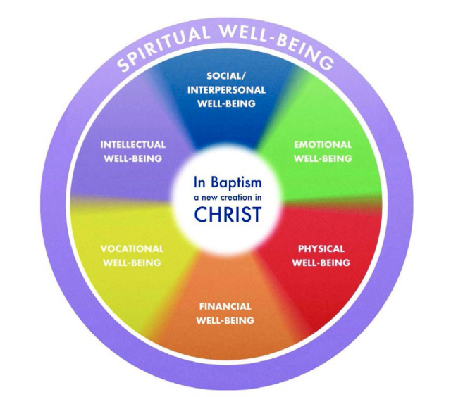
The deeper our faith, the more doubt we must endure; the deeper our hope, the more prone we are to despair; the deeper our love, the more pain its loss will bring: these are a few of the paradoxes we must hold as human beings. If we refuse to hold them in hopes of living without doubt, despair, and pain, we also find ourselves living without faith, hope, and love. ~ Parker Palmer

“The journey to genuine transformation, to emotionally healthy spirituality, begins with a commitment to allow yourself to feel.” ~ Peter Scazzero

Two Core Questions for Our Time Together:
- How are you personally tending to your own emotional health, and consequently your spiritual well-being?
- How do we engage our emotions in a healthy way that allows us to be more connected and transformed for the sake of a deeper faith, hope, and love

I. What Have You Learned About Emotions?
- For many it is hard to recognize emotions, let alone understand them. Few of us were raised to be curious about emotions and talk about them.
- We live in a world, society, culture, and church that often diminishes their importance.
Common Stories that Dismiss Emotions (Brené Brown, Rising Strong):
- Being emotional is a sign of vulnerability and weakness
- Don’t ask. Don’t tell. Nothing is gained by sharing emotions.
- We don’t have emotional language so we stay quiet or make fun of them.
- Discussing emotion is frivolous, self-indulgent, and a waste of time
- We are so numb to feeling that there is nothing to feel
- Uncertainty is to uncomfortable
- Engaging and asking questions invites trouble.

II. What Do You Do With Your Emotions?
- “95% of things that go wrong are because we are unaware.” ~ Brené Brown
- We live in a world, society, culture, and church that often diminishes their importance.
- Jesus at Gethsemane – brutally honest and in touch, yet absolutely submitted
Unhealthy Ways We Deal with Emotions (Brené Brown, Rising Strong):
- Chandlering (Stoic) – “I’m fine”…until grazed
- Bouncing – blame, anger, avoidance
- Numbing – taking the edge off of pain (alcohol, work, books)
  - You cannot selectively numb (if you numb the dark, you will also numb the light)
- Stockpiling – shoving emotions down and not feeling
  - The body will pay for unprocessed emotions (ACE’s)
- High centered – can’t go forward, can’t go back (stuck)
- Umbridge (Not integrated) – Everything is great, but…it’s not

III. What Barriers Do You Face In Dealing With Emotions In A Healthy Way?
- External barriers & expectations of a pastor?
- Internal barriers and expectations you have of yourself as a pastor?

IV. What Does Emotional Health Look Like?
Emotional health begins with pausing (stillness) & listening
- Often our lives can get reduced to multiple committees, endless work, one activity to the next, the next new learning, etc. The tyranny & tiredness of the busy and the urgent.
- “Ignoring our emotions is turning our back on reality; listening to our emotions ushers us into reality. And reality is where we meet God”. ~ Dan Allender, The Cry of the Soul
- We must be willing to experience and listen to our emotions for the burdens, hopes, needs, and barriers they present

Practice – burdens, hopes, & needs: ______________________________________________________
____________________________________________________________________________________

Emotional health involves recognizing, naming, and tending to our emotions for the purposes of love and connection with God & others.

- Recognizing
10 Core Emotions:
Anger Sadness Fear Contempt Excitement
Joy Surprise Disgust Shame Guilt

- For many, recognizing emotions can be very difficult. Our bodies often provide the first clue.
- What the boom in neuroscience is showing us:
  - “We make the mistake of believing that we are thinking beings capable of feeling. We are, in fact, feeling beings capable of thinking” ~ Dr. Jill Bolte Taylor, PhD, Neuroscientist
  - Emotions are the primary way we take in the world
    - If you want to substantially change thought or behavior, you begin with emotion.
- To recognize emotions we must become curious
  - Metaphor: A coffee date
    - Invite to get together
    - Tell me more about you…
    - What’s happening when do you feel that way?
    - How does that cause you to think/behave?

- Naming
- “Emotions are not the heart, but they are the voice of the heart.” ~ John Eldredge
- Emotions reveal the stories we are telling ourselves about who we are and how we see the world and those around us.
- Jesus invites naming and attunement to our desires - “What do you want?”

- We need to remain curious to the point of understanding what our heart is speaking.

- Who do we name our emotions to?
  - Ourselves
    - “Almost all problems in the spiritual life stem from a lack of self-knowledge.” ~ Augustine
  - Others - community
  - God (Immanuel) – connection vs. deliverance

- Naming evokes vulnerability – uncertainty, risk, & potential of emotional pain
  - Vulnerability’s paradox:
    - It is the cradle for intimacy, love, connection, & belonging
    - “Shame dies when stories are told in safe spaces” ~ Ann Voskamp

Practice - Feeling, story, belief (what feels true?): ___________________________________________
____________________________________________________________________________________

- Tending
- Tend to emotions by engaging with them vs. avoiding them (i.e. numbing, over-exercise, over-eating, suppression, “taking every thought captive” cut off, excessive study, detached praise)

- Embrace them as a part of our God created humanity.

- Weather metaphor
  - Emotions like weather can blow in, change, can be mild or intense, and pass through
  - As with weather we analyze, respond, & adapt to them

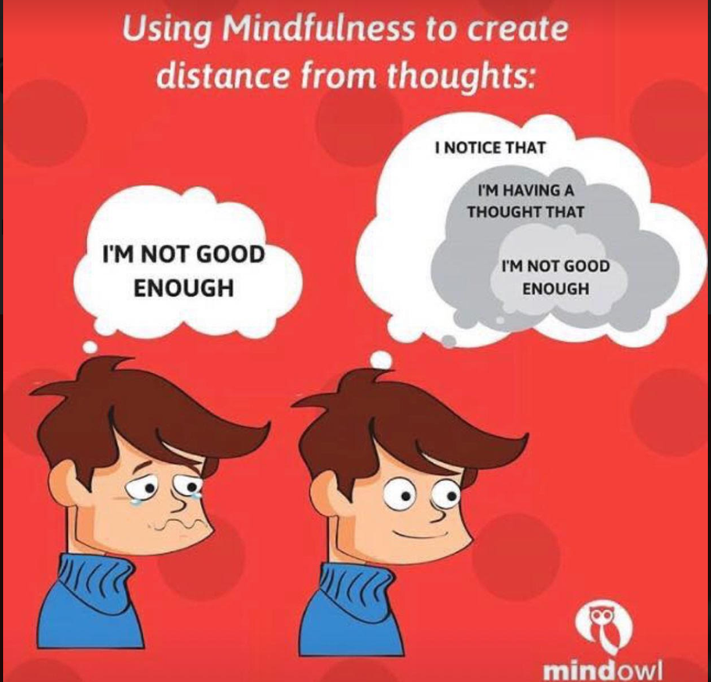
- Separate emotions from identity
  - Reminder: Emotions are not the heart, but they are the voice of the heart
  - Mindfulness is a practice of providing you space from your emotions and thoughts in order to observe, listen, and rumble with them.

- Rumble and work with the stories our emotions are telling us
  - What is truly true? – “You shall know the truth and the truth shall set you free”
  - Allow for the both/and
    - I am loved, and I struggle with depression
  - Luke 4 (Not enough temptation)
    - I am what I do – performance
    - I am what I have – possession
    - I am what others think – popularity
  - “When we deny our stories, they define us. When we own our stories, we can write a brave new ending” ~ Brené Brown

Practice - Rumbling: __________________________________________________________________
___________________________________________________________________________________

- Loving & Connecting

- What is the end goal of healthy emotional engagement?
  - To be more self-actualized and aware?
  - To get to pain free?
  - To better regulate our anxiety, our depression, the intensity of our emotional reactions?
  - To manage our relationships

- We must ask - “What is our ultimate vison? What is our ultimate purpose?

Emotional health involves recognizing, naming, and tending to our emotions for the purposes of love and connection with God & others.

- Emotions are the means, they are not the end goal

Matt 22:37-40: Jesus replied: “‘Love the Lord your God with all your heart and with all your soul and with all your mind.’ This is the first and greatest commandment. And the second is like it: ‘Love your neighbor as yourself.’ All the Law and the Prophets hang on these two commandments.”

- Our emotions provide a doorway to engage with the deepest levels of our heart, the weight of our truest desires.

- This is the territory of transformation - the place of where our image of God is healed, our wounds are mended, and our hearts are freed.

- All of which releases us to more deeply love and connect in the manner for which we were created.

Application Plan:

#1 Develop a practice to listen to and pay better attention to your emotional interior
- Practices: Journaling, listening prayer, activities of silence and solitude

- Patiently wait for deeper emotions to be revealed

- Consider your deepest longings

Plan: __________________________________________________________________________________
_______________________________________________________________________________________

#2 Seek the support & community of a trusted friend with whom you can share your heart
- “Few shed their false self without a trusted companion along the way…With such a friend we share the deepest desires of the heart, so we can support one another in arranging our lives in ways we are congruent with what our heart most wants.” ~ Ruth Haley Barton, Sacred Rhythms

Plan: __________________________________________________________________________________
_______________________________________________________________________________________

#3 Be willing to rumble with yourself, with God, and stories of your emotions
- Explore and get honest about the stories behind your emotions and what they are saying

- Challenge the stories you are telling yourself that you know are not consistent with the truth

- Be still and invite God to speak to you in these deep places

- Reflect upon and write a new narrative consistent with the truth

Plan: _____________________________________________________________________________________
__________________________________________________________________________________________

#4 Identity how healthy emotional engagement moves you to greater love and connection
- Consider how you want to more deeply love God and others

- Reflect on how healthy emotional engagement can support this desire

- Write down the behavior, feelings, and thoughts of love you want to hold

- Identify actions you can take to more deeply connect with others

Plan: __________________________________________________________________________________
_______________________________________________________________________________________

